

Daffodil International University

Department of Computer Science and Engineering

Faculty of Science and Information Technology (FSIT)

Mid Term Examination, Semester: Fall - 2017

Course Code: CSE311 (Day) Course Title: Database Management System

Section: All Course Teacher: All

Time: 90 minutes Total Marks: 25

Answer all questions

**Consider the following scenario to answer Q1: 8**

Although you always wanted to be an artist, you ended up being an expert on databases because you love to cook data and you somehow confused `data base' with `data baste.' Your old love is still there, however, so you set up a database company, ArtBase, that builds a product for art galleries. The core of this product is a database with a schema that captures all the information that galleries need to maintain. Galleries keep information about artists, their names (which are unique), birthplaces, age, and style of art. For each piece of artwork, the artist, the year it was made, its unique title, its type of art (e.g., painting, lithograph, sculpture, photograph), and its price must be stored. Pieces of artwork are also classified into groups of various kinds, for example, portraits, still lifes, works by Picasso, or works of the 19th century; a given piece may belong to more than one group. Each group is identified by a name (like those above) that describes the group. Finally, galleries keep information about customers. For each customer, galleries keep their unique name, address, total amount of dollars they have spent in the gallery (very important!), and the artists and groups of art that each customer tends to like.

**Q1.**Draw the ER diagram for the database. Be sure to indicate cardinality constraints

**Consider the following ER Diagram to answer Q2: 4  
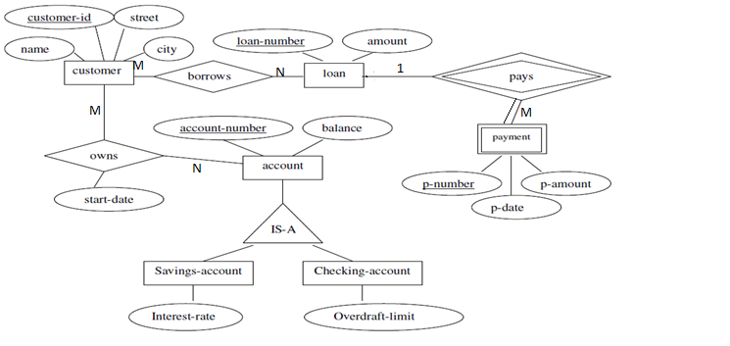Q2:** Convert the ER diagram into a relational database schema. Be certain to indicate primary keys and foreign keys.

**Consider the following schema to answer Q3:** **8**

Consider the following schema for a database where the primary keys are given. Give an expression in SQL for each of the queries.

**Course** (CourseID, Course_name, semester)

**Student** (sID, sName, CGPA, Age)

**Takes** (sID, CourseID)

1. Add another field in Student table, named as “Email” and give the data-type of that field as variable character which must be size of 10.
2. Find the IDs of Students who have taken Database Management System or Distributed Database course.
3. Find the names and cgpa of student whose cgpa is better than some student called Azizul Islam.
4. Find the average age of students for each subject that has at least two students.

**Q4:** a)What are the DDL and DML commands in SQL. State with examples **3+2** b)What is ACID properties in Database Management System? Explain the first one.